What to do today

1. Read a dictionary entry
- Read Dictionary Entry.
- Use different colours to show the different parts as indicated.
- Look at the Revision Card. Why does the word ‘Fast’ have two versions?

2. Find out about some words
- Read the words on Word Grid.
- Use a dictionary or the dictionary website to work out what they can mean.
https://kids.britannica.com/kids/browse/dictionary
- The words in blue might belong to more than one word class.
- Choose three words and make dictionary entries for them, using the Template.

3. Write some sentences
- Write sentences that use the words from the Word Grid.
- Challenge yourself to write a crazy story that uses all these words at least once!

Well done! Now show a grown-up your story. Talk to them about the meanings of the words from the Word Grid.

Try these Fun-Time Extra
- Can you find five new words in the dictionary that you don’t think anyone in your house will know.
- Learn to spell them, learn what they mean and then impress the people you live with!

Dictionary Entry

plumber noun
A person whose job is to fit and repair things such as water pipes, toilets, etc.
I think we’ll have to call the plumber to fix that tap.

wooden adjective
To be made of wood.
The karts were wooden.

fast adverb
To move quickly.
She drove fast in her kart.

fast adjective
Moving or capable of moving at high speed.
He won as he had a fast bike while my car was too slow.

Use different colours to show these parts of each entry:

- The word
- The word class
- A definition
- An example sentence

The first has been done for you.

Make a key to show what your colours mean.
Revision Card – Word Classes

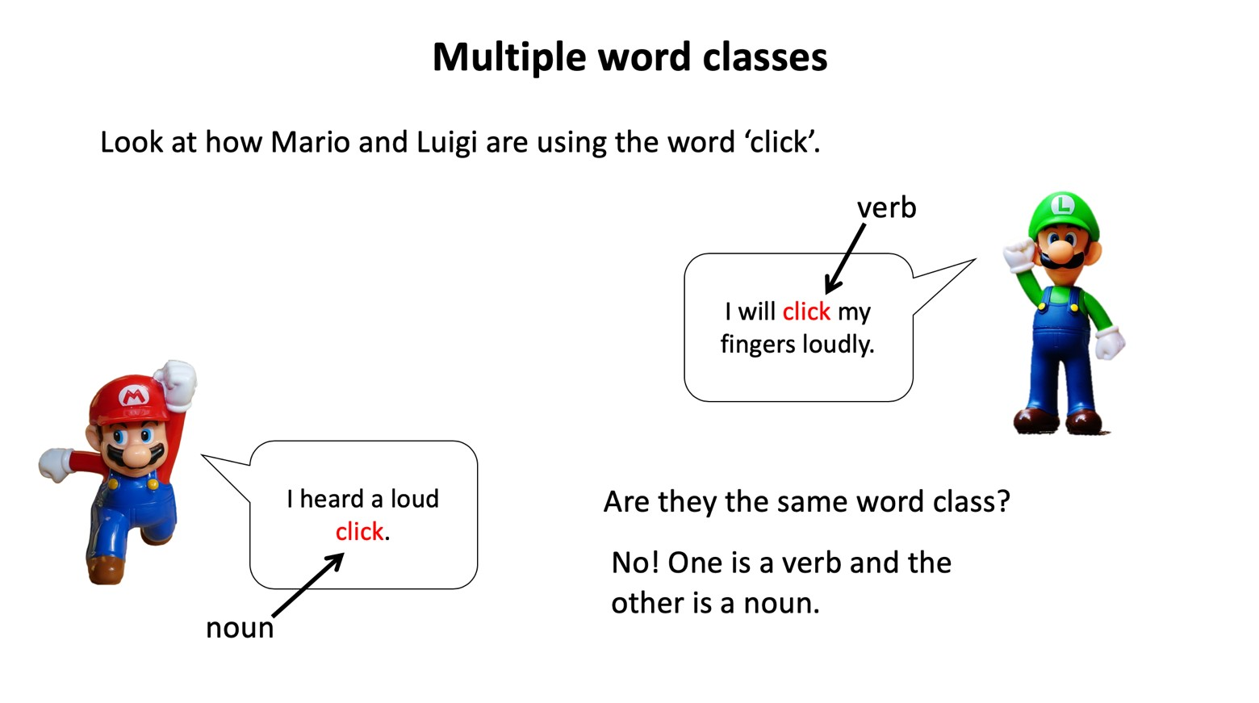
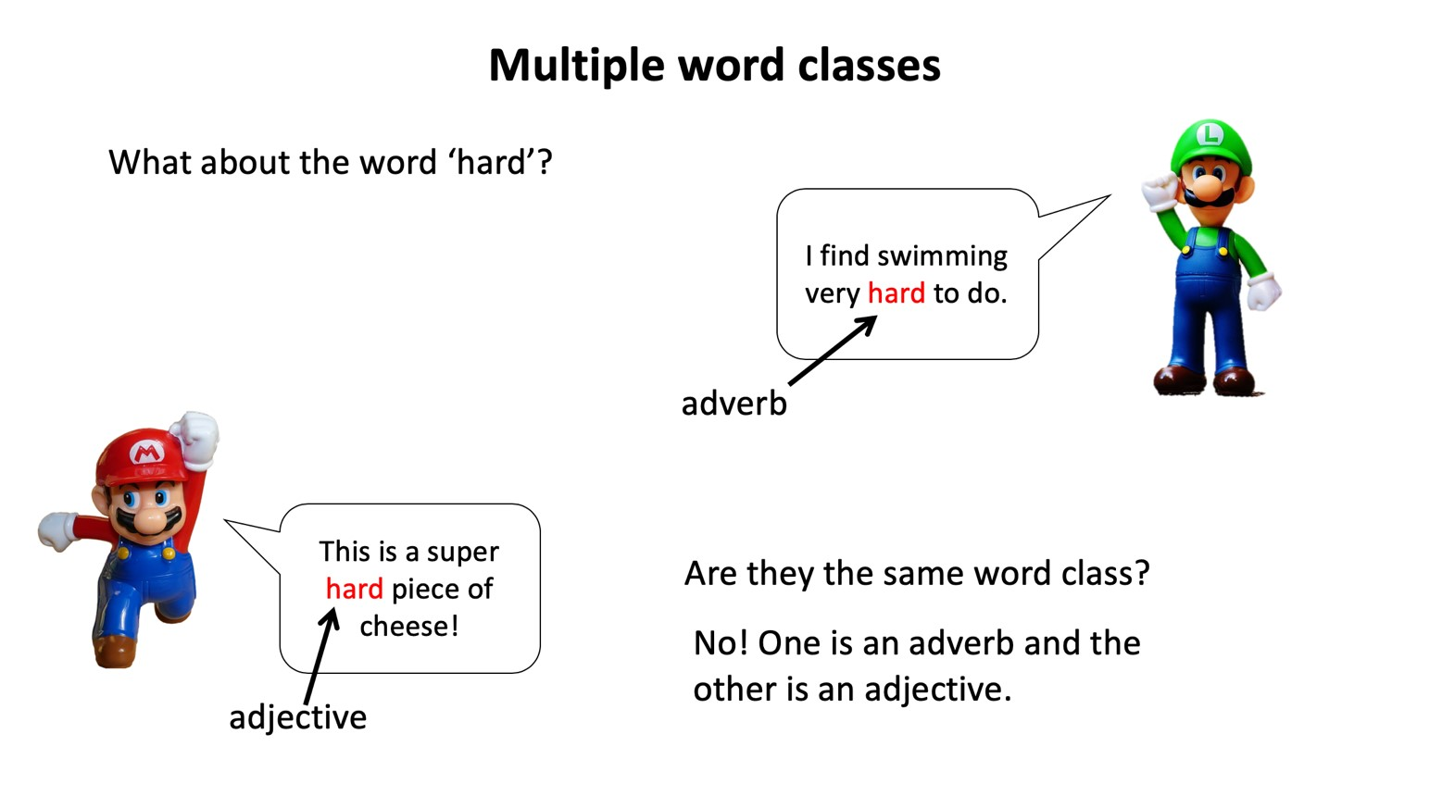

spikey | plumber | difficult | kick
slowly | jump | run | fast
bumpy | track | kart | trick
hard | level | race | aggressively
high | skid | helmet | wooden
Word grid

3

Dictionary definitions template

Word Grid Writing

Write sentences that use some of the words from the Word Grid OR Challenge yourself to write a crazy story that includes all of them.

