Hello to all the Y4s from Mrs Lowe and Mrs Waggott!
We hope you are all keeping well. We are both ok but missing you all.
The home learning for today is:
Maths, English, PE and D&T.

Maths
L.O. To interpret bar charts
Today we are moving onto another topic in maths called ‘statistics’. This is going to be all about answering questions about different types of graphs, collecting data and drawing your own graphs.
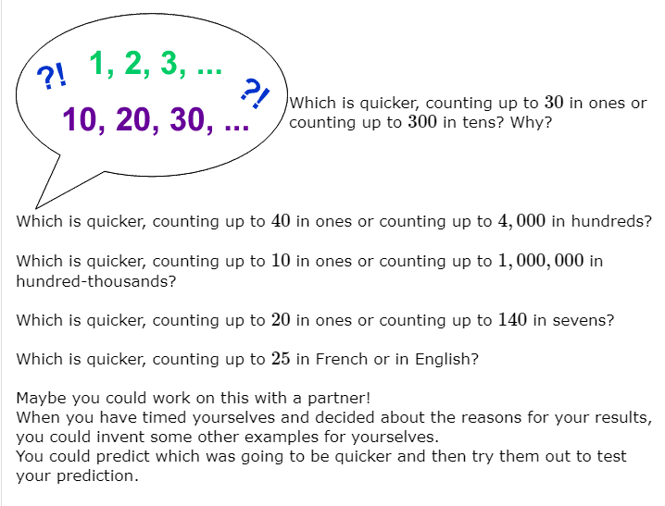
Here’s an activity to get you warmed up!
Watch the video below which explains the different types of graphs and tables we can use:
https://www.bbc.co.uk/bitesize/topics/zfr3nrd/articles/z8dp8mn
This lesson is about reading bar charts and interpreting them (finding the answers). Go through the PowerPoint that we have uploaded first.
Then have a go at the sheets we have uploaded. Either try one, two or all three of them. For each sheet, there is a space at the bottom for you to create your own questions about the bar chart. Maybe you could challenge your parents or an older brother/sister?
The answers are also included so you can check how you have got on. You can write your answers on the sheet or on a separate piece of paper.

English
L.O. To read a text and answer questions about it
Today for English, you have two options.
Option 1 is a reading comprehension with questions to answer. There are three different levels of difficulty - * is for those who don’t feel too confident and *** is the most challenging. The answers are included too for you to check. This is a good option to choose if you are not an overly confident reader and would prefer a straightforward task. The files are attached. You can print the sheets out, or read the text on the screen and write your answers on a piece of paper.
Option 2 click on the link below and follow the lesson on BBC Bitesize. There are three activities and they are all about a book called ‘The Worst Witch’. This is a good option to choose if you are a confident reader and would like more of a challenge. The questions are all about reading between the lines and inferring what you think the author meant.
https://www.bbc.co.uk/bitesize/articles/z7rrcqt
Or – try both!!

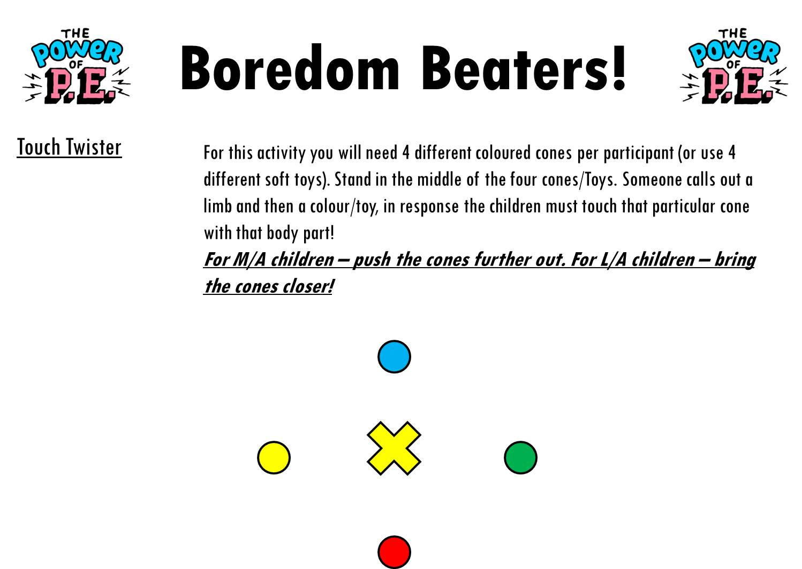
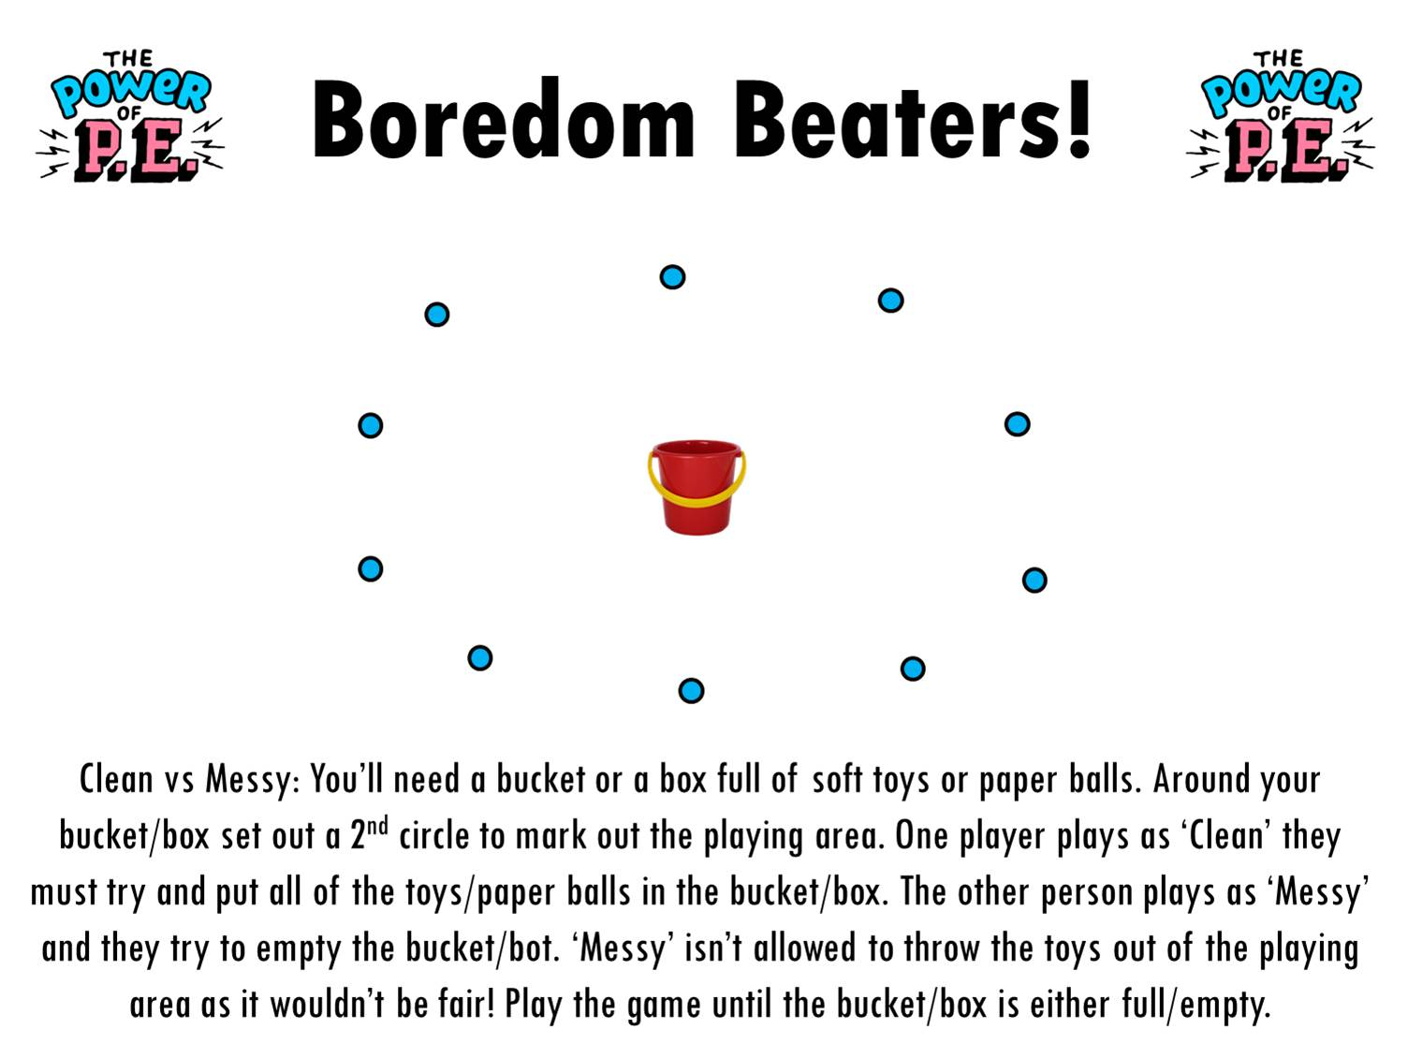
PE

D&T
LO: To research designs and create a design criteria, aimed at a particular group.

Look at the pictures of different bug hotels (attached).

Watch:
https://www.bbc.co.uk/newsround/49051965

Follow the link (https://www.bbc.co.uk/newsround/47195749) to find out more about why insects are so important.

Make a list of design criteria for your own bug hotel.
What do you want yours to be like?

E.g:
· I want to make a Bug Hotel for minibeasts to live in for my garden.
· I want it to be made from recycled and natural materials.
· I want it to be an attractive design
· I want it to be inviting for insects and bugs.
· I want to be able to observe the bugs inside.
· It needs to be well- made (not fall apart).

Do the pictures meet your design criteria?
Choose two pictures of bug hotels you like and make notes, labelling them, on what they have (good and bad), according to your design criteria.
See WAGOLL (attached)

