**Minibeast Habitats**

Write the name or draw a picture of the minibeast you find and where it lives.

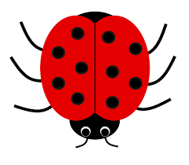 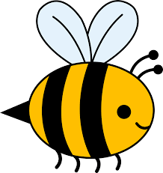 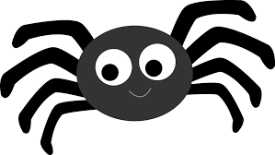 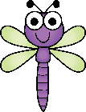 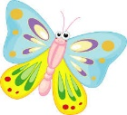 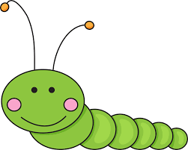

|  |  |
| --- | --- |
| **Minibeast** | **Where found?** |
|  |  |
|  |  |
|  |  |
|  |  |

*Challenge – Why do you think these minibeasts like to live in these places?