Section of the life cycle | How long it lasts | Fraction of life cycle
Egg | 5 days
Caterpillar (or larvae) | 2 weeks and 3 days
Chrysalis (or pupa) | 1 week and 3 days
Butterfly | 15 days
Scaffold
LO: To represent the life cycle of a butterfly
- Complete the table to show the fraction of the life cycle each stage is.

- Use this information to complete this bar model (there are 50 squares to complete) – shade in the right amount and match it to the key.
Key
Egg
Caterpillar
Chrysalis
Butterfly

- Write next to each of these pictures which stage it is from and fill in the gaps with information to explain that stage. Finally, write a number next to each stage to order them.
Here are your words to choose from:
chrysalis metamorphosis caterpillars larva quickly skins leaves pupa two weeks
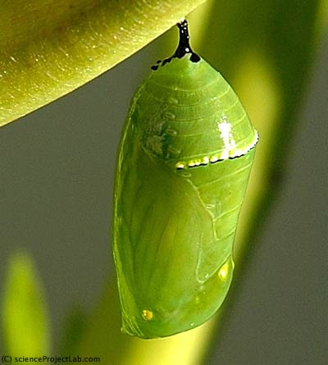
After a few weeks the caterpillar attaches itself to a twig and forms a hard outer shell called a chrysalis or _______________. There is no eating during this stage, this is the time where the caterpillar undergoes _________________________ and transforms.

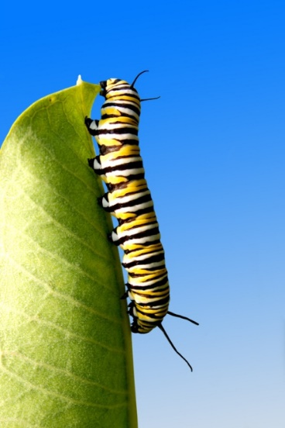
___________________ or _________________ eat a huge amount of leaves so this stage is sometimes called the eating stage! Caterpillars grow very ________________ and have to shed their ____________________ many times as they grow out of them. They then eat their skins as well!

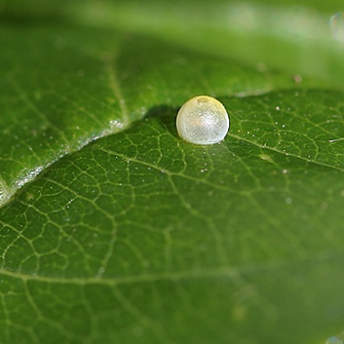
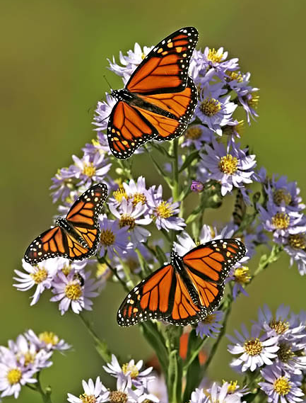
A butterfly begins its life as a small white egg, which are often laid on _____________________.

The fully formed butterfly emerges from the __________________, dries its wings and then flies off to seek out a mate. It will only live for around 2 _________________.

