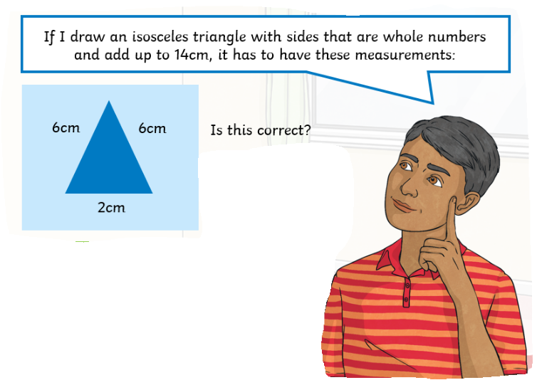
Are there any other measurements that would work for an Isosceles triangle?
Adam says that he can draw a right angled triangle which has another angle which is obtuse.
Is he right?
Explain why.

