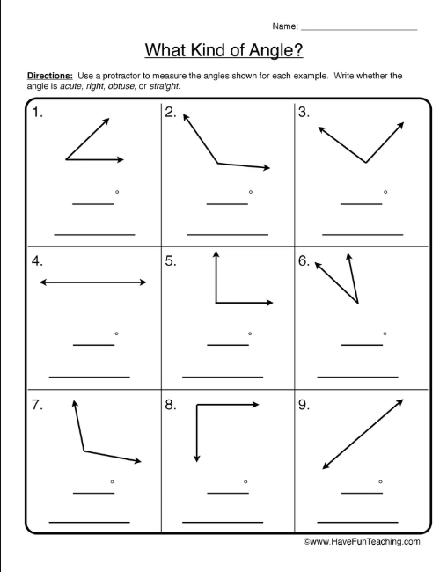

Directions – Use your angle eater to determine what type of angle is shown. Write whether it is acute, right, obtuse or straight.