Year 5 – Home Learning
Friday 24th April
Lesson and Learning Objective | Task
LO Compliments to 1 | Search White Rose Home Learning – Year 5  Click on Summer Term Week 1, Lesson 3  This objective is all about finding the complements which sum to make 1 (in other words all the different ways you can make 1, eg 0.5 + 0.5 =). As you are completing todays task see if you can see the links with number bonds to 10, 100 and 1000 as this will help when you start to find complements to 1, with numbers that have three decimal places. If it would help use a hundred square, part-whole models and number lines to support your learning today.  I’ve also attached a mental arithmetic test. Set your timer for 20 minutes, and don’t forget to check all your answers! You’re aiming to get all of them right.
English  LO:  To identify the key events in a legend | Read the version of Robin Hood attached. Which parts of the story do you think are most exciting? Choose one bit that you think is exciting and make a short list to identify what the author has done to make it more exciting (such as varying sentence length for effect or ellipsis).  Now you need to identify/summarise the key events from the story – bullet point these – remember it is only the key events!  Here is an example of a tension graph – can you see it looks quite like a line graph?  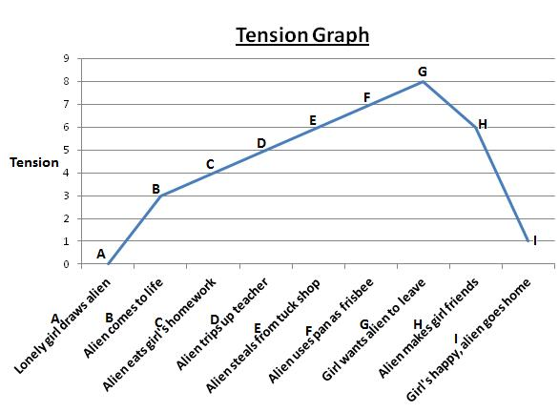  Up the y axis we have degrees of tension (from low tension at the bottom and more tension as you go up the axis. Along the x axis we will plot the key events of the story. Here is an outline for Robin Hood.  You will be creating your own tension graph of Robin Hood following the steps to success:  - Draw your x and y axis and label them to match the yellow WAGOLL  - Place the key events you have identified along x axis, as you would for a normal bar chart/line graph  - Place the scale of tension up the y axis – remember to put these values ON the line, not IN the box  - For each event, rate the level of tension and plot this on your graph  - Join your plots up with straight lines to finish your tension graph  As always, we would love to see your work so feel free to send in a photo to your teacher via email!  Challenge (for those children who want an additional challenge when completing the task) – Can you give examples on the next page as to how the author has achieved this level of tension?  Support (for those children who may require more support to complete the task) – See the scaffolded tension graph attached – you can choose the one from above or just squared paper.
Reading  LO: To infer characters’ feelings by finding evidence from the author’s word choice. | Y5 Reading Task 24/4  LO: To infer characters’ feelings by finding evidence from the author’s word choice.  Read pages 24-30 and answer the following questions. Write your answers underneath the questions.  Infer what the author means through the choice of words in these extracts. You may need to read around the extracts to get an idea as to what’s going on in this part of the book.  - What is the author trying to convey to the reader (show to the reader) about Julian here?  While she was talking, I noticed Julian staring at me out of the corner of his eye.  For example:’ I think Julian is staring at him out of the corner of his eye to show that he is curious about how he looks, but does not want to stare.’  - What is the author trying to convey to the reader (show to the reader) about Julian here?  “Oh yeah, whoopee,” said Julian, twirling his finger in the air.  - What is the author trying to convey to the reader (show to the reader) about Jack’s character here?  “Come on, August, “ said Jack. “Let’s just go to the library already.”  Write down the definitions for the following words:  Strict  Incubator  Jerk
Spelling | Check out the new spellings for the week,
Wider Curriculum  What does it mean to be resilient? | PSHE – What does it mean to be resilient? Have a read of the attached sheets below – how will you choose to celebrate resilience?

