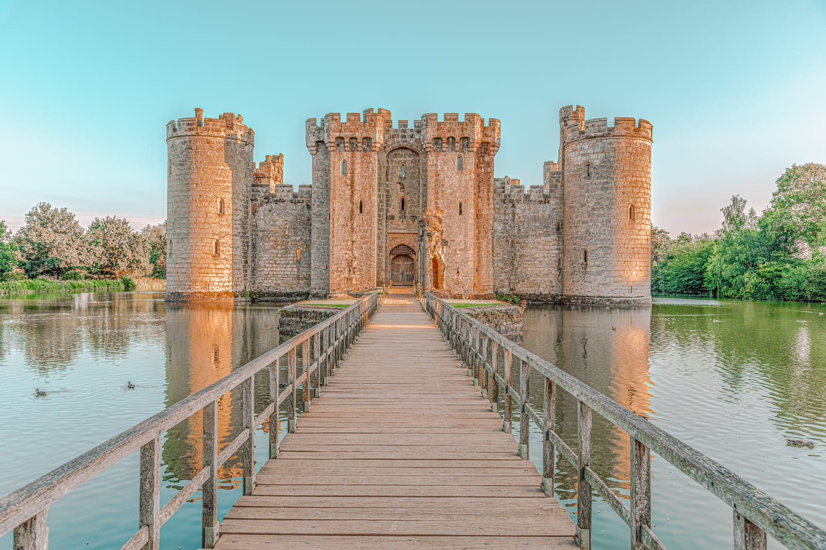Main activity

B_____________________________

M­­_____________________________

R___________________T______________

A_____________L_________

Found around the castle, ______________

______________ were used to _____________

_________________________ _________________________ _________________________.

C________________W_______________

The job of the _______________________ ______________ was to _________________ _________________________________________

_____________________________________________.

G____________________D___________________

This area of the castle was often the _________________. The main gate or door was usually made from _____________________ so that ____

_____________________________________________

_____________________________________________.

M­­_________

An effective defence for the castle, __________ meant that ___________________________________________________________________________________________.