Music
Tuesday 25.2.2021
Task 1
Today, you will need 2 pieces of A4 paper (it doesn’t matter what colour you use) because you will be making two paper fans to use in a Jasmine Flower Fan Dance. You will also need 2 strips of sellotape.
LO: To link movement to a pentatonic piece of music
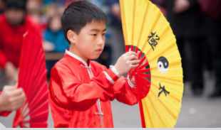
Last lesson, we looked at how Chinese instruments are classified and learnt about one woodwind and one string. We also used Chrome Music Lab (Song-Maker) to compose a piece of music for a graceful fan dance. We used the pentatonic notes in C Major; pentatonic uses the 1st, 2nd, 3rd, 5th and 6th notes of a scale, for example:
In C major, we have the following notes : C D E F G A B C
C | D | E | F | G | A | B
1st | 2nd | 3rd | 4th | 5th | 6th | 7th
So, the pentatonic notes we use will be: C, D, E, G and A

Fan dances are ancient; they developed as a way to share stories, preserve the culture and communicate feelings and emotions without words. They are still performed in ceremonies such as Chinese New Year. Fans are thought to be good luck charms and also expressions of generosity. Click on the link to see a fan dance:
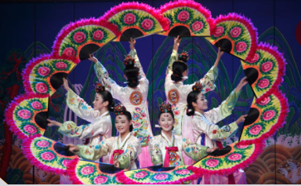
https://www.youtube.com/watch?v=HUxNesJZKy4
Now, have your two pieces of paper in front of you and sellotape. If you want to decorate your fans, I would recommend decorating both sides of your paper and do this before you start the video below. Make it colourful – felt tips, gel pens, even glitter if you’d like! Since we are going to perform movements to a Jasmine Flower fan dance, you may wish to decorate it with:
- jasmine flower drawings
- pentatonic note names (remember to use capital letters for note names)
- notation
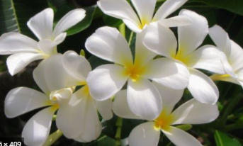
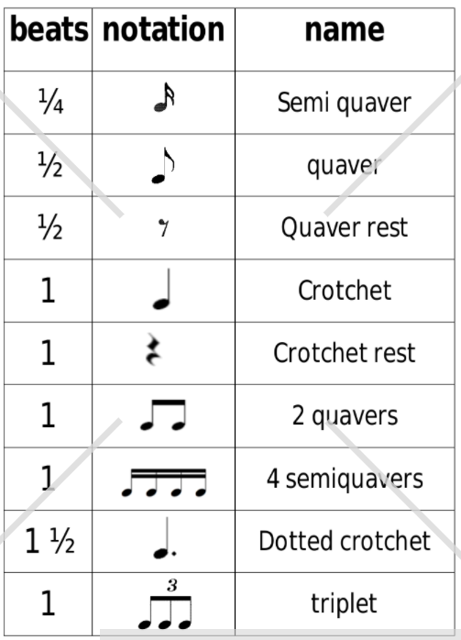
Jasmine flowers:
Notation:

Click on the link below and follow the instructions:
https://www.youtube.com/watch?v=PU_xrc9r8H8
You can take a picture of the details on your decorated fans and post on Class Dojos
Challenge: If you enjoyed the fan dance and have time, create your own tune on Music Lab Song-Maker like we did in the last lesson (remember to change the settings to Pentatonic); melody in the top, base chords in the bottom). Add your own actions whilst it is playing!
Task 2
Have a go at clapping the following Lunar rhythms! Fun fact: the title logo for Lunar relays the message of ‘Happy New Year’ in five different languages, each from a different country that celebrates the Lunar New Year!
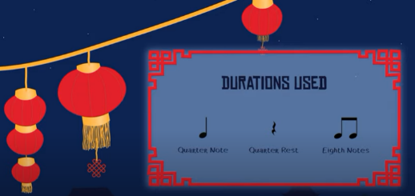
- Easy mode uses crotchet and quaver note duration as well as a crotchet rest.
Remember, a crotchet = 1 beat, a quaver = ½ a beat, so 2 quavers must be clapped in the same time as a 1 beat. https://www.youtube.com/watch?v=qgxysSW1neQ

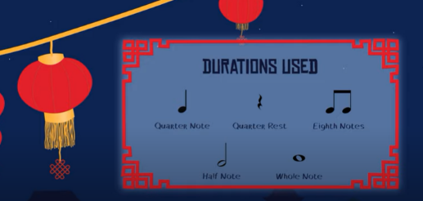
- Intermediate mode uses crotchet, quaver, minim and semibreve durations as well as a crotchet rest.
A crotchet = 1 beat, a quaver = ½ a beat, a minim = 2 beats and a semibreve = 4 beats. https://www.youtube.com/watch?v=hzIGcdo26uU

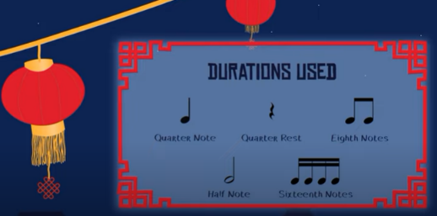
- Challenge mode uses crotchet, minim, quaver, and semiquaver durations as well as a crotchet rest.
A crotchet = 1 beat, a quaver = ½ a beat, a semiquaver = ¼ beat and a minim = 2 beats.
https://www.youtube.com/watch?v=MxZF618WVRA
I hope you enjoy today’s music!

