L.O. To identify common appliances that run on electricity
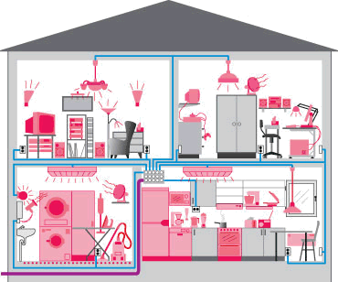
Key:
Mains –
Battery –

