- Set up a backdrop. This could be a wall or a table turned on its side.
- Gather toys to include in your animation.
- Set up your touch pad or smart phone, leaning on something or on a stand or tripod – this is the really important but tricky it as it needs to remain COMPLETELY STILL.
- Start the Stop Motion Animation App and make your movie using the following steps.
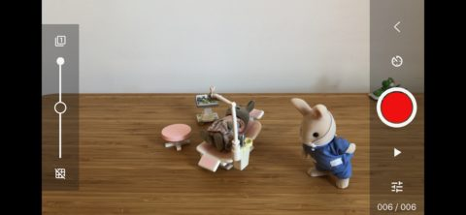
- Open the app and press + New Movie. Make sure the shot is framed properly and hit the camera icon in the top right corner.
- Hit the record button to take each shot, moving your scene along in between. The smaller the movements, the smoother the animation will be. Use the timer button above the record button if you want to automatically take shots at a regular interval.
- Hit the play button below the shutter button to instantly preview your animation.
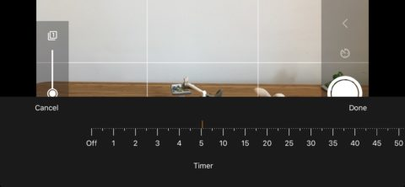
Challenge - Extra tools to try
- The tool button to the bottom left lets you apply a shooting grid. Press and hold it, then tap + to add safe areas, paths for your figures to follow, drawings and more (some of which are premium features).
- The button to the top left of the viewfinder enables the ‘onion skin’ effect, which overlays previous frames to help you with proper alignment.

