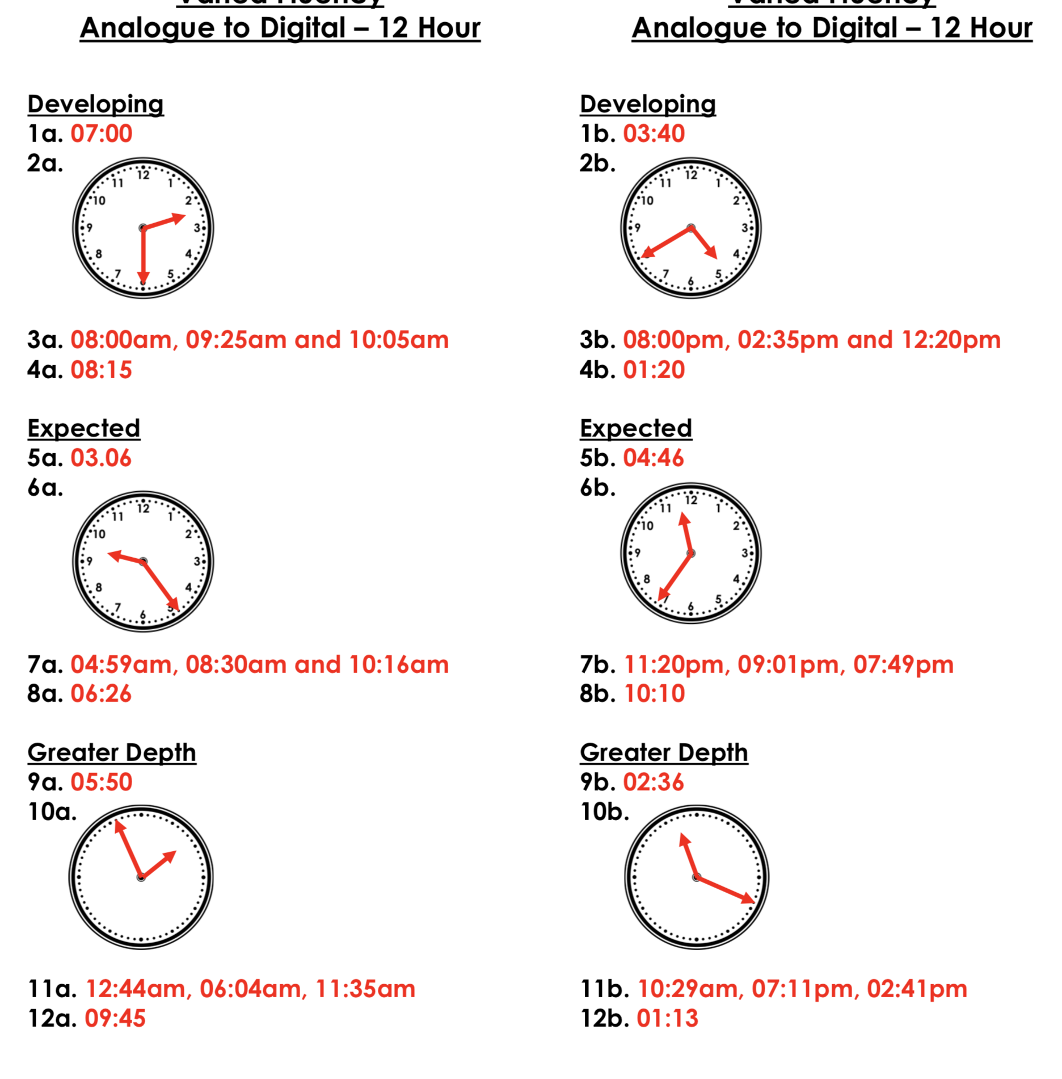

Developing – 1 star
Expected – 2 stars
Greater Depth – 3 stars

