Lesson 3
LO: To develop a design for a particular group
(WAGOLL)
Bug Hotel for minibeasts to live in, to go in a garden.
Clear plastic end of milk bottle – waterproof for protection against the weather

Stones for spiders to hide under
Bits of tree bark for woodlice

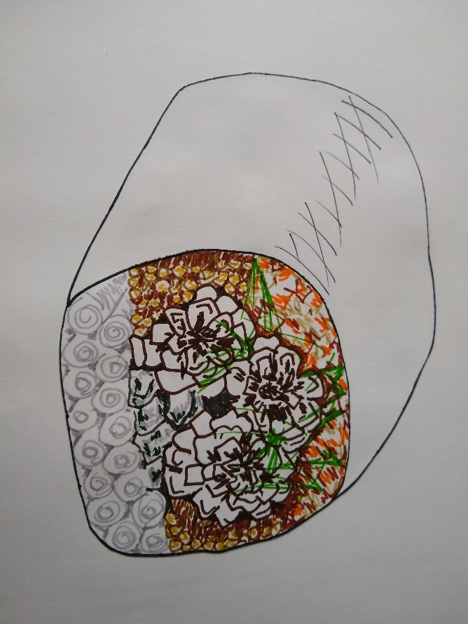
Tightly rolled up newspaper for lacewings

Pinecones for earwigs

Twigs
for ladybirds

Moss to mimic a forest floor

Bits of grass for insulation

