Lesson 2
LO: To research designs and create a design criteria, aimed at a particular group.
(WAGOLL)
Design criteria for my Bug Hotel:
- I want to make a Bug Hotel for minibeasts to live in for my garden.
- I want it to be made from recycled and natural materials.
- I want it to be an attractive design
- I want it to be inviting for insects and bugs.
- I want to be able to observe the bugs inside.
- It needs to be well- made (not fall apart).
Tiny bugs should be warm and snug.
Rolled up newspaper

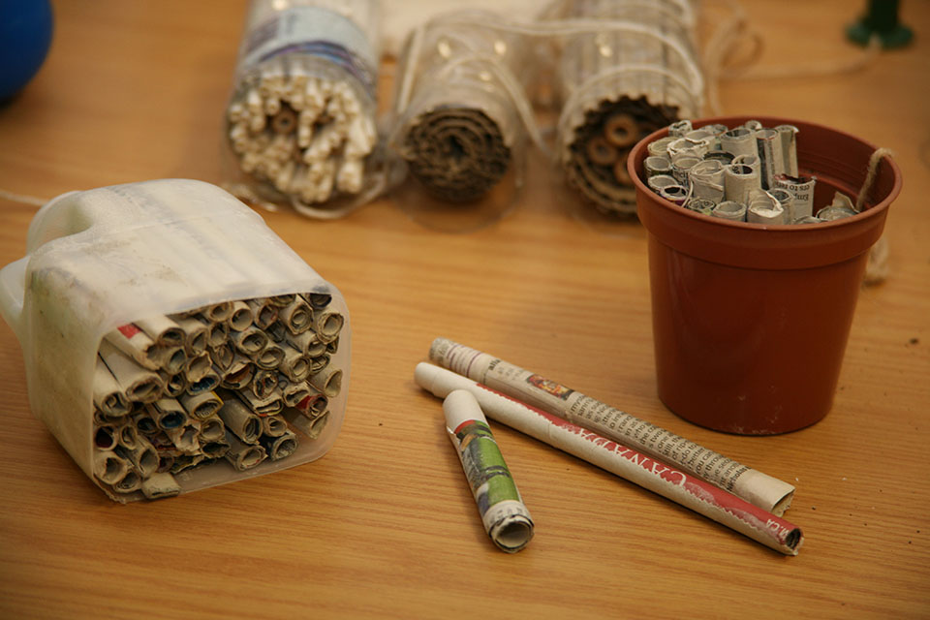
Protected by plastic bottle casing and good for observation.
Tightly packed in so it doesn’t fall out.

Can be wedged between tree branches
Not very attractive.

Colourful tin can protecting materials inside but not good for observation.

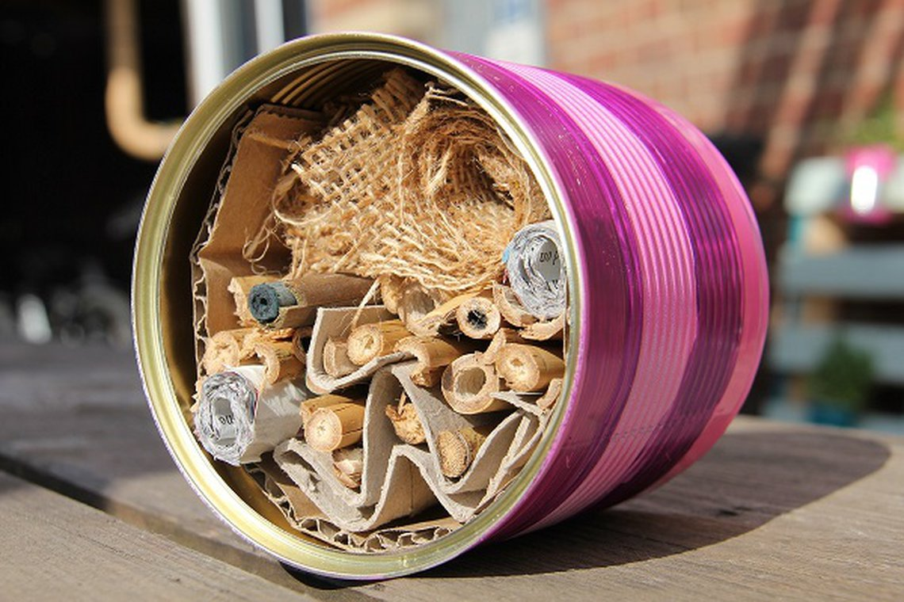
Could be sharp at the top of the tin.

Tightly packed in so it doesn’t fall out.

Inviting for bugs

Recycled and natural material

Attractive in my garden

