**Solutions**

1. What is our school canteen called? Corn on the Cobcroft **1 mark**
2. How goal posts are there on the field? Two goalposts **1 mark**
3. Name 4 of our school values. **4 marks**

Appreciation

Compassion

Co-operation

Courage

Creativity

Determination

Encouragement

Freedom

Honesty

Humility

Kindness

Loyalty

Resilience

Resourcefulness

Respect

Responsibility

Thoughtfulness

Trust

1. How many classes are there at Dobcroft? 14 (including cornerstone) **1 mark**
2. Name all the Y6 teachers- spelt correctly. **3 marks** *Mrs* Conroy, *Miss* Taylor, Mr Harrison , *Miss* Harper
3. What is on the display outside the Y6 toilets, above our coat pegs? **1 mark**

The 3D rainforest display

1. How many Y6 classrooms have sinks in them? **2 marks** 2 classrooms
2. What is the bench called on the front yard where people can sit if they feel a little lonely and would like a friend to play with? The Buddy Bench **1 mark**
3. What days are Y6 PPA days? Monday and Wednesday **2 marks**
4. What was the Y6 trip called where we were taught how to stay safe in different situations. Crucial Crew **1 mark**

**Paper 2**

1. Bounty
2. Lion Bar
3. Mars
4. Double Decker
5. Kit kat chunky
6. Yorkie
7. Mint Aero
8. Boost
9. Snickers
10. Milky Way
11. Fudge
12. Toffee Crisp
13. Cadbury Caramel
14. Turkish Delight
15. Picnic
16. Crunchie

**Paper 3**

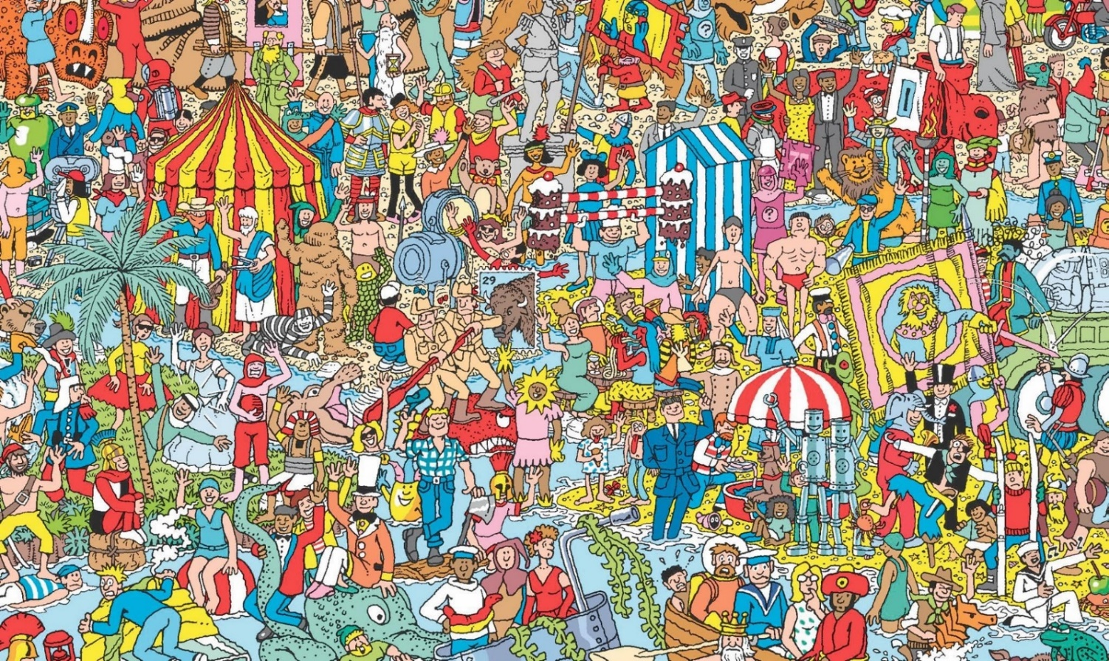

**Paper 4**

Mr Harrison - This teacher has run 15 half marathons

Miss Taylor- This teacher had performed at Glastonbury four times

Mrs Conroy - This teacher has ridden a zebra

Miss Harper - This teacher can solve a Rubik’s cube in a few minutes

**Paper 5**

Timed task

**Paper 6**Art task

**Paper 7**

1. You!

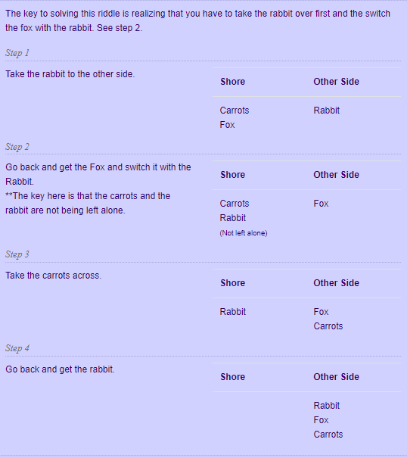

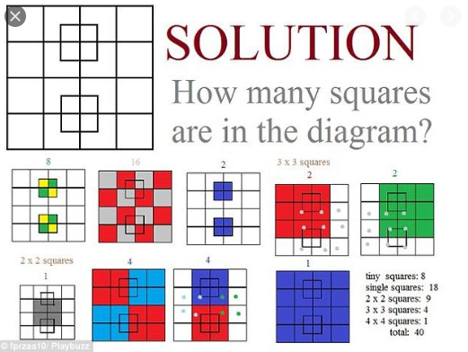



**Paper 8 - Reading**

1. **Cat in the hat**
2. **The Hungry Caterpillar**
3. **Matilda**
4. **Green Eggs and Ham**
5. **3 Little Pigs**
6. **Alice and Wonderland**
7. **James and the Giant Peach**
8. **Harry Potter**
9. **Charlotte’s Web**
10. **Charlie and the Chocolate Factory**
11. **The Rainbow Fish**
12. **Tiger came to tea**
13. **Black Beauty**
14. **We’re going on a bear hunt**
15. **The lion, the witch and the wardrobe**

**Paper 9**

Secondary schools – different answers

**Paper 10**

Celebration hairstyle task