**Square**

I have 4 equal sides.

I have 4 right angles.

I have 2 pairs of parallel sides.

I have 2 pairs of equal sides.

I have 4 right angles.

I have 2 pairs of parallel sides.

**Rectangle**

**Rhombus**

I have 4 equal sides.

I have 2 acute angles and 2 obtuse angles.

I have 2 pairs of parallel sides.

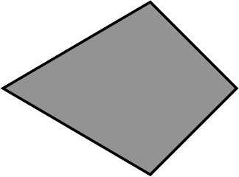

I have 2 pairs of equal sides.

My angles are not all the same.

I have no parallel sides.

**Kite**

**Parallelogram**

I have 2 pairs of equal sides.

I have 2 acute angles and 2 obtuse angles.

I have 2 pairs of parallel sides.

My 4 sides are not all the same.

My 4 angles are not all the same.

I have 1 pair of parallel sides.

**Trapezium**