Name and Drawing of Object | Simple Mechanism  (levers, pulley, inclined plane, wheel, cog) | What forces does it help with?
Wheel barrow  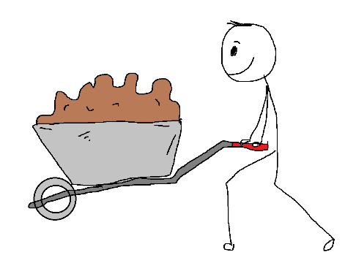 | Lever – with the wheel as a pivot and the handles as the beam.  Wheel | A wheel barrow makes it easier to lift and move heavier objects across a garden.

