Year 5 – Home Learning
Monday 20th April
Lesson and Learning Objective | Task
Maths  L4 Percentages as fractions and decimals  L5 Equivalent Fractions, decimals, percentages. | Search White Rose Home Learning – Year 5  Click on Week 2  Lesson 4  Now you’re going to move on to representing percentages as fractions using 100 as the denominator and making connections to decimals and hundredths. By the end of the lesson you’ll begin to recognise percentages, decimals and fractions are different ways of expressing proportions.  Lesson 5  This is the last lesson of this topic when you begin to recognise simple equivalent fractions and represent them as decimals and percentages. Try to ensure you are secure in your knowledge of the percentage, decimal and fraction equivalents of ½, ¼, 1/5, 2/5, 4/5. There’s plenty of games on the internet to help. Always think about denominators being multiples of 10 or 25. Bar models and hundred squares can help to support your understanding.  I’ve also attached an Ultimate Maths Sheet, only give yourself 90 seconds to complete.
English  To apply technical vocabulary. | LO: To apply technical vocabulary  We come across castles as a setting in the story of Robin Hood and therefore we need to develop our knowledge of this. Take a look at this picture of a castle:  Rally Robin with somebody at home what you already know about castles, their purpose or the features. What would you like to find out/what would be useful to know about castles? Conduct some research on http://primaryhomeworkhelp.co.uk/castles/defence.htm – making notes about key parts and their roles.  Using this research, follow the Steps to Success to complete your task:  - Either draw your own image of a castle or use the one above  - Label the key parts of the castle  - Ensure at least 4 of the parts have a function or purpose written alongside it  Challenge (for those children who want an additional challenge when completing the task) – Ensure that you use a formal, informative tone, maintaining the use of technical language.  Support (for those children who may require more support to complete the task) – Use the attached sheet to label the directed parts and extend the sentences using the starters given.
Reading  To retrieve key information. | Continue the Robin Hood theme by completing this Robin Hood Comprehension. Read the text first and discuss what it is about. Look at the questions and highlight the key information you are looking for, write your answers on paper. For those who need more support see separately attached comprehension.  Try and use full sentences:  For example:  - Robin Hood had only taken ______ onto the bridge.  The Real Robin Hood  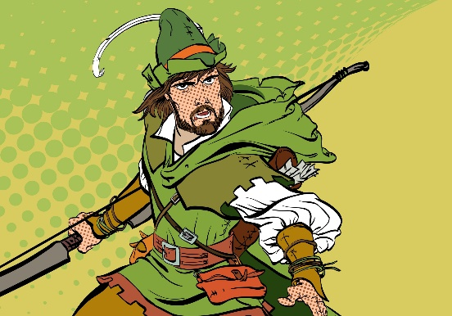  Robin had only taken a few steps onto the bridge when there was a flurry of movement at the other end. Either side of the bridge, men with bows erupted from the foliage; their arrows aimed at Robin and Will. One of the men started to cross the bridge towards them. The man was one of the tallest that they had ever seen. He was a whole head taller than Robin. He carried a long staff as thick as a man’s wrist and he was grinning from ear to ear - flashing his teeth at the two weary travellers. “Look sharp!” Robin hissed at Will.  “Bridge tax!” the tall man bellowed, “stand where you are!” The two of them continued to edge further forwards until Robin was standing face to face with the brigand. “You cannot come across this bridge without paying the fee!”  With unnatural speed, Robin had pulled an arrow from his quiver, nocked it and was now stood with his drawn bow pointing in the giant’s bearded face. “Now, now…” said the Giant taking a step backwards, “there is no need for that.” Robin took half a step towards the bandit who suddenly swung his staff violently, knocking Robin’s bow into the river; sending his arrow flying off to embed itself into the trunk of a nearby by tree.  The outlaw laughed, “if you want to fight rather than pay, then it needs to be a fair fight.” he said as he handed Robin another staff. “If you can knock me, Little John, from the bridge then I will waive the fee.”  Robin let out a deep sigh as he hefted the staff. ‘Little John?’ he thought to himself, ‘the man is as big as a bull and twice as fierce!’  R How far onto the bridge was Robin when John appeared?  V Which words show that the men appeared quickly?  E Explain how you know that this story is set in the past.  I What is Robin thinking/feeling when he ‘let out a ‘deep sigh?’  S How does Little John earn money?
Spelling | Carry on practising your usual spellings for the week.  You could also challenge yourself to choose at least 8 words from the technical vocabulary activity and make sure you can spell them correctly.
Wider Curriculum | Spring is springing all around us! Create a piece of art that celebrates this. Have a look at this simple image below. They have used finger prints to create a beautiful blossoming tree. On your next opportunity to have some exercise outside think about how you could sketch or paint signs of spring. You can use paper you have at home or recycle some card from a cereal box. Think about all the different mediums you could use. Pencils, paint, stencils or perhaps even flower pressing. Get creative and let us know what you have made.  

