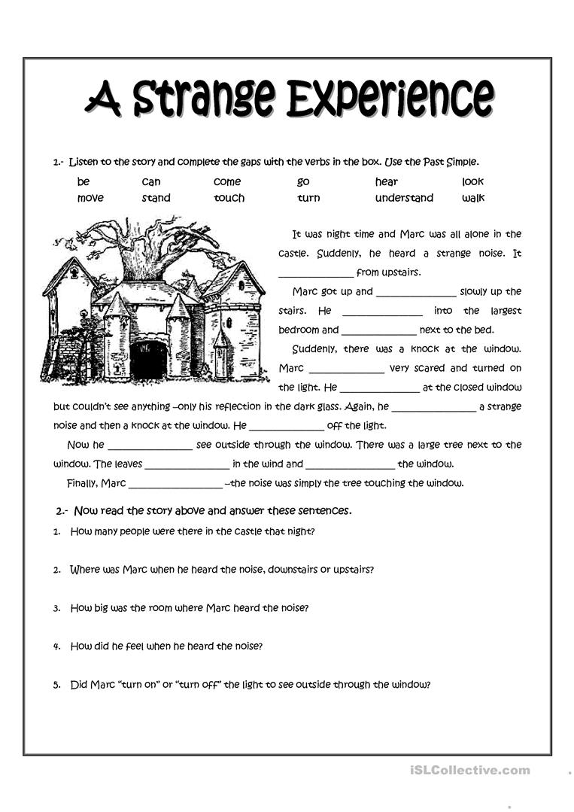

Monday 20th Blog y5.

Supported Reading comprehension