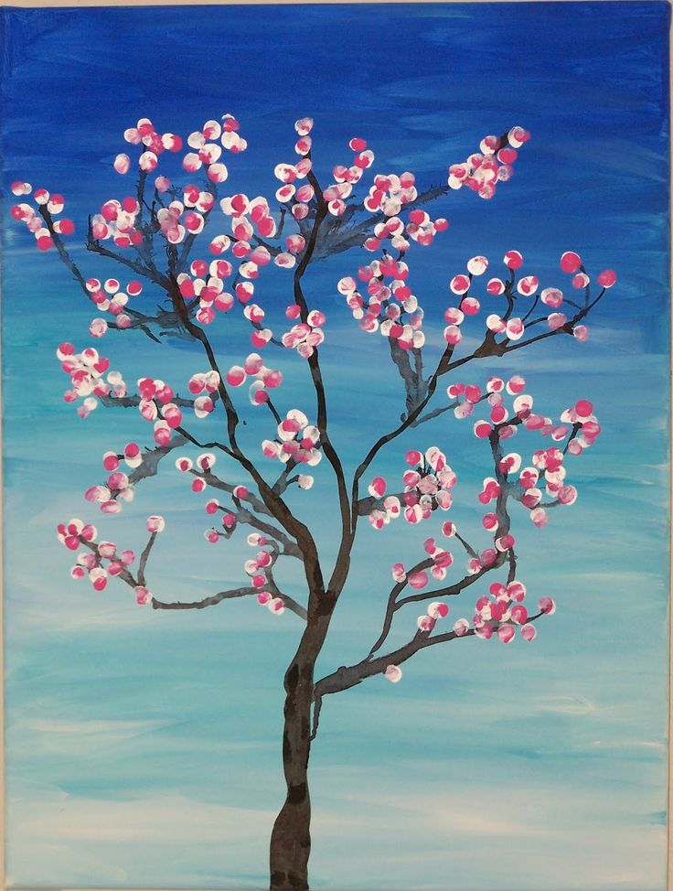

Art: How can you represent spring?

This pupil has used a simple finger print to create a beautiful image of a blossoming tree.