A World Without Books…
By Y3J
A world without books is like…
A body with no heart,
A tooth with no dentist,
A sea with no lifeboats,
A princess with a broken tiara
A flower without a beehive,
The Sun without heat,
A soul with no friends,
An X-Box with no games,
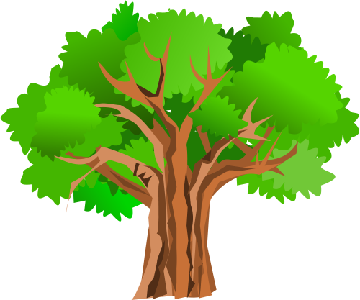
A kid without friends,
A toilet with no flush,
A toothbrush without paste,
A bird without feathers,
A wolf with no claws,
A farm with no animals,
Cinderella without her prince,
A crispy duck without pancakes,
A school without children,
A fish with no water,
Day without night,
A picture without colour
A house with no roof,
A world with no land
A rainbow without colour,
A hall with no happiness,
A world without books is like a planet without life.
A world without books is like Y3J without US!

