Name of education setting: Dobcroft Junior School

If you have any concerns about a student at this setting please share this information with us straight away. Issues such as appearance, hygiene, behaviour, can be shared with teaching or support staff. Do not worry about reporting small matters – we would rather you tell us than miss a worrying situation.
However, if you think that a student or an adult who cares for them has been or might be harmed; please talk to a member of our trained safeguarding team immediately (details below).
You can ask any member of staff to find them and speak to you about a confidential and urgent matter.
If you are unhappy with the way we have dealt with something, please tell us. If you wish to report it to us formally please use our complaints procedure or write directly to the Head Teacher or Chair of Governors.
A concern, allegation or disclosure of abuse involving someone working with children or adults in a paid or unpaid capacity must be reported directly to the Head Teacher, Principal or Senior Manager, unless it involves them and then it should be reported directly to the Chair of the Governing Body or Management Committee.
This document can be laminated & given to parents, carers, supply staff & visitors at reception, to help them to identify your safeguarding team quickly & share information easily

Name: Nicola Sexton
(Head Teacher)
Their office is located next to:
The office
Their tel. no is: 01142368075

Our Designated Safeguarding Lead is:
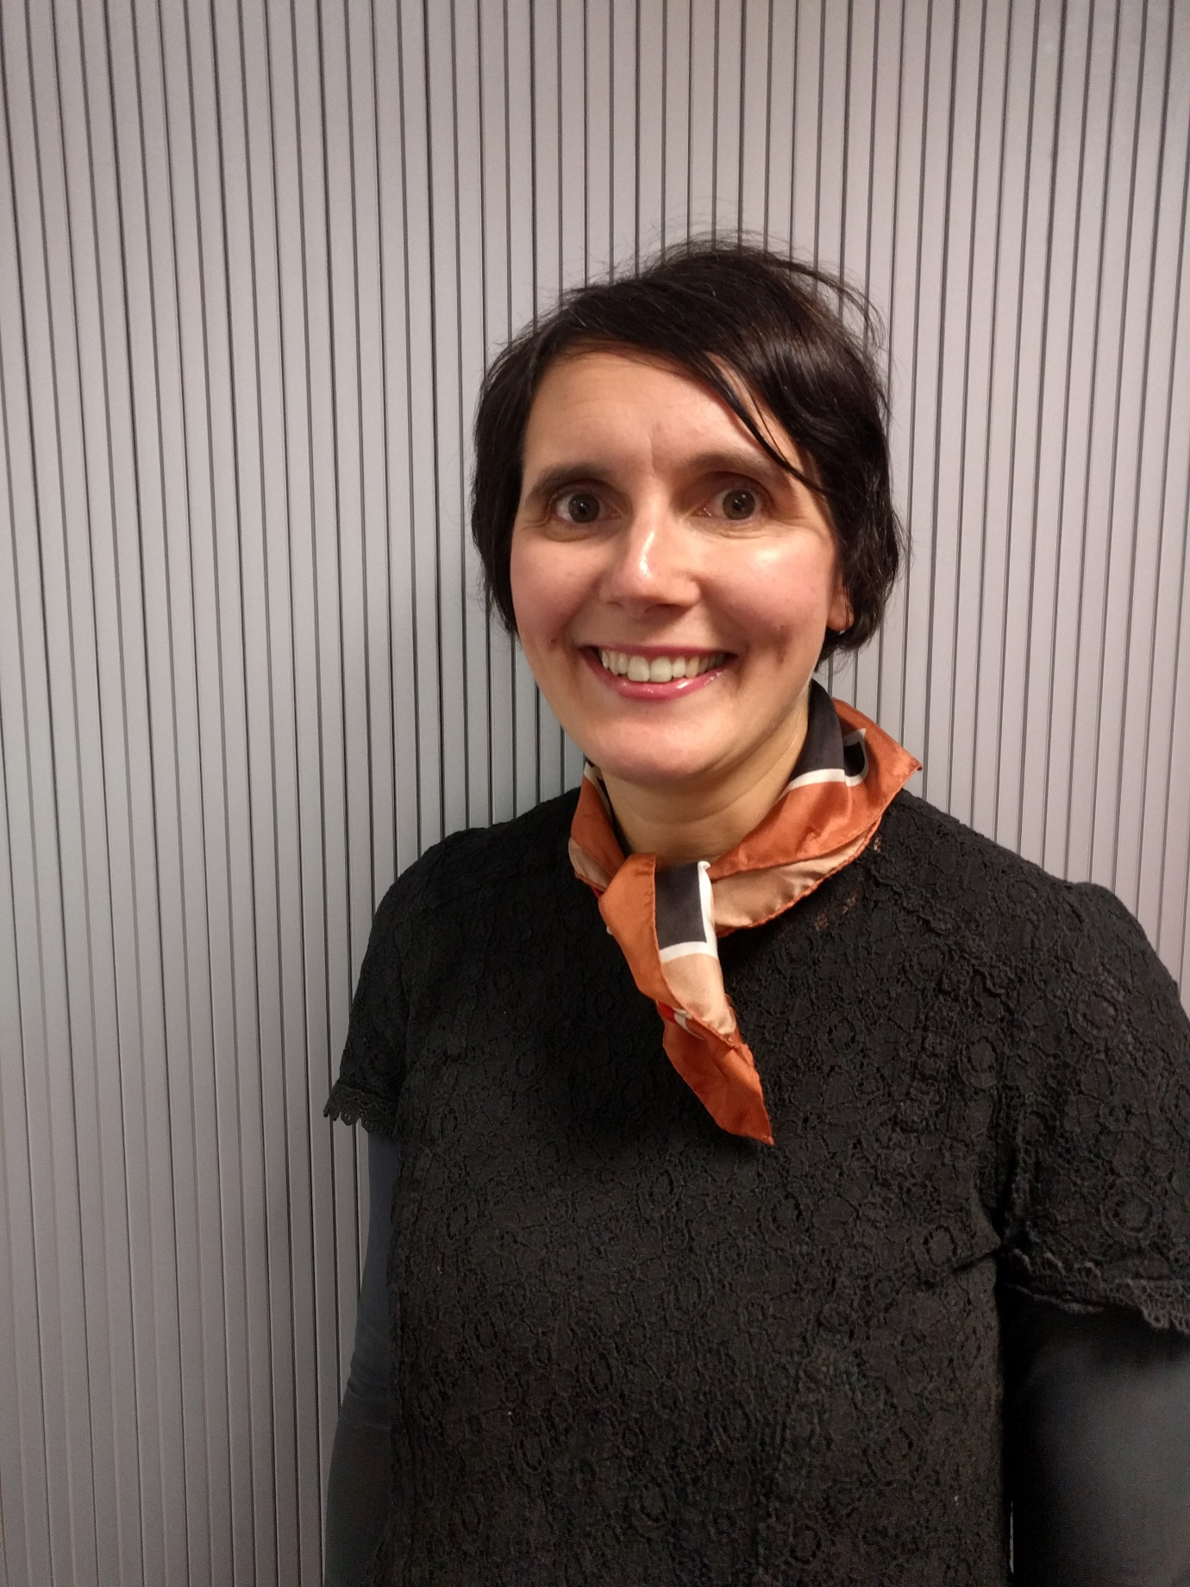

Name: Louise Fear
(Pastoral and Family Support Leader)
Their office is located next to:
Y3SH Classroom
Their tel. no is: 01142368075

Our Designated Safeguarding Deputy is:
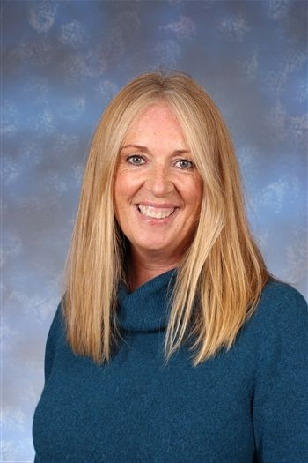

Our Chair of Governors (or equivalent) is:
Name: Paul Shawley
Their tel. no is: 01142368075
Their email address is:
chair@dobcroft-jun.sheffield.sch.uk

Name: Sheree Doyle (Deputy Head Teacher)
Their office is located next to:
The office
Their tel. no is: 01142368075

Our Designated Safeguarding Lead is:
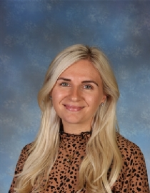

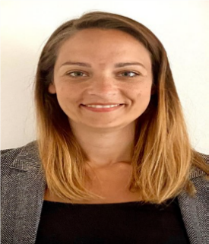

Our Special Education Needs Coordinator is:
Name: Hayley Little
Their office is located next to:
The office
Their tel. no is: 01142368075

Our Safeguarding Governor (or equivalent) is:
Name: Andrew Davies
Their tel. no is: 01142368075

