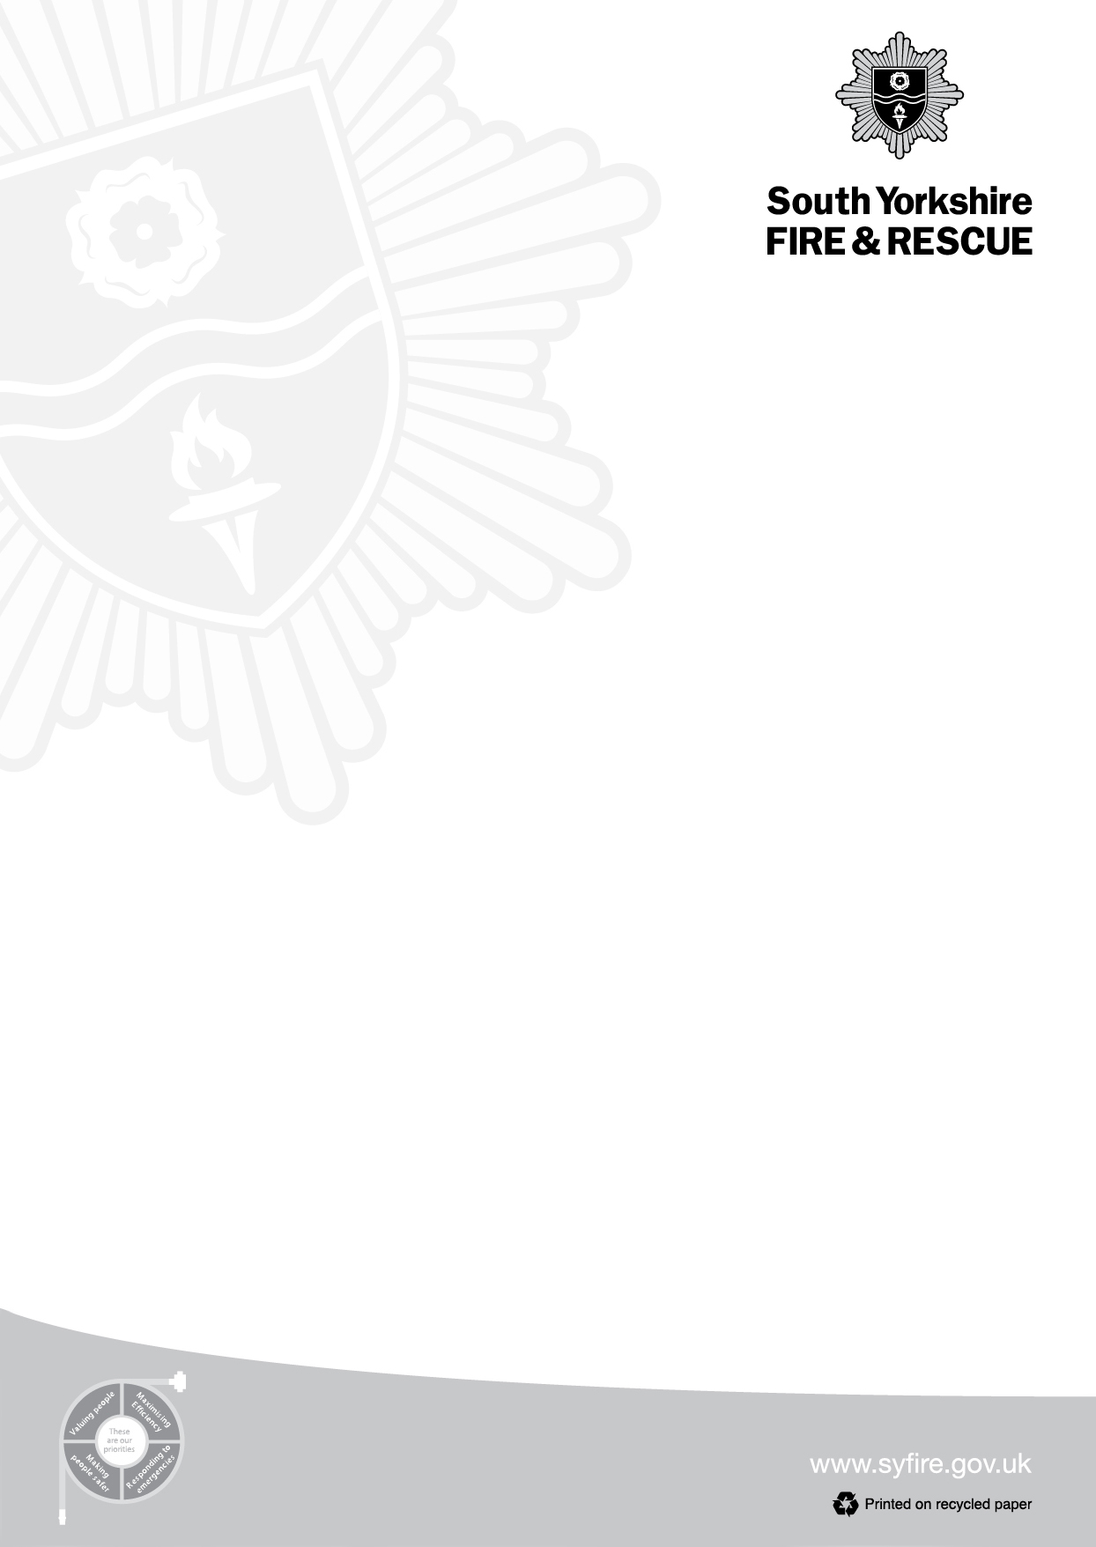

197 Eyre Street

Sheffield

S1 3FG

Tel: 0114 2727202

Fax: 0114 2532266

**Chris Kirby**

Chief Fire Officer & Chief Executive

Date: 14/07/2023

Dear Parents,

South Yorkshire Fire and Rescue would like to bring to your attention the dangers of young people entering open water and offer you some water safety advice for your family.

**Our key messages, for children of all ages across the county, are:**

* **Tombstoning**: Never jump, dive or ‘cannonball’ into open bodies of water such as rivers, lakes, quarries and oceans. You don’t know what’s underneath the surface or how deep it is.
* **Cold water shock**: The UK is a cold water country which means no open water is above 15 degrees. A public swimming pool is between 26-28 degrees. Many fatalities are caused by the cold temperature and how it affects someone when they enter the water. Firstly it causes a deep intake of breath, during which dirty water will usually be mixed with the air breathed in. Blood will be directed to their core to protect major organs, restricting supply to their arms and legs which are needed for swimming. This makes it very difficult for someone to swim and is often how lives are lost.
* **Infection:** Open water can contain raw sewage as you may have seen in the news recently. Diseases you can catch include Hepatitis A & C, Weil’s, E-coli and Botulism.
* **Debris:** In all our open water sites we have found floating driftwood, shopping trolleys, broken glass which can affect your ability to get out and also cause serious injury.
* **Swimming safely:** We recognise that organised open water swimming, be that in land or on the coast, has a wide array of physical and mental health benefits in a safe environment. You should only swim where it’s safe and legal – swimming pools, outdoor lidos, with an open water club or other sites were lifeguards are present.

Don’t give in to peer pressure from your friends and jump into the unknown. It could be the last thing you do.



**What to do if you or your friends get into trouble in the water**

* Should you get into trouble in the water you should float to live (tilt your head back with ears submerged, try and relax and use your hands to stay afloat). Try to stay calm and just focus your energy on floating and shouting for help or gather your energy before swimming to safety.
* If you see someone in trouble in water call 999 and ask for the fire service. Keep your eyes on them until we arrive and don’t attempt to go in yourself and put yourself at risk.
* **What 3 words**: - Please make all young people aware of this location app. Download it to their smartphone so that if they do get into difficulty we can locate them efficiently, even if they are in a remote area.

If you are visiting the coast this year ensure children are supervised by an adult at all times and only swim where lifeguards are present.

**For more advice on enjoying the water safely go to** [**www.rlss.org.uk**](http://www.rlss.org.uk) or [**www.rnli.org**](http://www.rnli.org)

Kind Regards,

South Yorkshire Fire and Rescue.